

The Nesbitt/Nisbet Society of North America

2025 AGM In Houston, Texas

with Election of our President for the 2026-2029 Term and

Treasurer for the 2025-2028 Term

The Nesbitt/Nisbet Society is inviting our members to join us in Houston, Texas for our 2025 Annual General Meeting (AGM) on October 16-19, 2025.

**The NASA Space Center and the Historic Johnson Space Center Tram Tour will be the main attraction.**

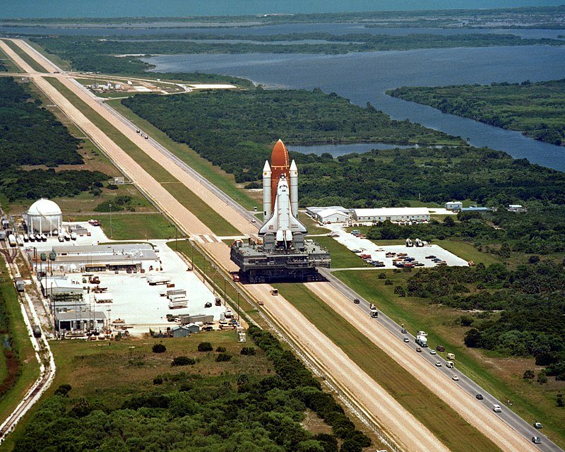

**We are excited to announce that Society member Stephen Nesbitt will assist with the tour and will be our quest speaker at the AGM business meeting. Stephen was the Public Affairs Officer for the Johnson Space Center and NASA's chief commentator who described the loss of space shuttle Challenger on January 28, 1986**, when the [Space Shuttle *Challenger*](https://en.wikipedia.org/wiki/Space_Shuttle_Challenger) broke apart 73 seconds into its flight above the Atlantic Ocean, off the coast of Cape Canaveral, Florida. It was the first fatal accident involving an American spacecraft while in flight.

During the business meeting, we will elect a new President for the 2026-2029 term and a new Treasurer for the 2025-2028 term. In addition, we will vote on a major revision to the Society’s Bylaws.

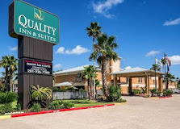We are planning a fun filled visit to Houston for our N/N guests. Make plans to bring the family and join us.

We will Stay at the Quality Inn and Suites Seabrook NASA Kemah where we have reserved a block of rooms at a discounted rate. View the [Quality Inn Booking Details](https://www.ibydeit.org/uploads/Quality%20Inn%20Booking%20Details%2012Jun2025.docx) to book your room by phone or online.

720 NASA Pkwy

Seabrook TX 77586

(281) 694-4004

‘Till then, best wishes,

2720 NASA Parkway

Seabrook, TX

David Harvey, IV, President

**The AGM Itinerary**

Thursday, Oct 16th: Arrive and Meet and Greet at the Quality Inn.

Friday, Oct 17th Day: Tour the NASA Space Center (the Space Station is open from 10:00AM-5:00PM daily). You will find many details about the tours, exhibits and rides by visiting it’s website, [NASA Space Center](https://spacecenter.org/). We’ll arrive at 10:00 AM with tickets and go to Guest Service Desk where you will book exciting tours, rides, and shows to fill up your day. This provides each member the ability to individually customize their experience.

We’ll start the day with[**Historic Mission Control Tram Tour**](https://spacecenter.org/exhibits-and-experiences/nasa-tram-tour/historic-mission-control/) from which NASA led Gemini and Apollo missions, including the momentous first lunar landing mission where the world heard Neil Armstrong’s famous words “Houston, Tranquility Base here. The Eagle has landed.”

**General Admission and Mission Control Tour:** Adult admission tickets for Friday are $29.95 and ther Mission Control Tour is $15.00 for a total price of $44.95. However, If we can get 20 members attending, we will be eligitable for group ticket pricing at $36.95 per person.

## **About the Space Center Houston:**

## A space center sign in a room AI-generated content may be incorrect.The Space Center Houston, a premier science and space exploration learning center, is dedicated to inspiring curiosity and fostering a love of science through learning programs and a world-class space museum.

As Houston’s leading attraction and the top destination for international visitors in the region, we proudly serve as the Official Visitor Center of NASA Johnson Space Center and a Smithsonian Affiliate. A flown SpaceX Falcon 9 rocket exhibit is now on display at Space Center Houston. Walk underneath this marvel of reusable space technology and learn how it is making space more accessible. Discover over 400 space artifacts, [immersive exhibits, and captivating experiences](https://spacecenter.org/exhibits-and-experiences/)  that celebrate the rich history and exciting future of America’s human space-flight program.

After the Space Center tour, you may want to check out the Independence Plaza exhibit, <https://spacecenter.org/exhibits-and-experiences/independence/>, Begin your journey through the shuttle era by taking the elevator to the top of Independence Plaza to explore the shuttle replica Independence. The first stop is the flight deck, where you will see how the astronauts piloted the orbiter during missions. One floor down, experience how cramped living conditions were on the mid-deck and walk out into the payload bay to see an actual flown artifact from STS-49, a satellite rescue mission in which three people from the same spacecraft walked in space at the same time.

Then the day is yours. NASA Tram Tours are the most popular experiences at Space Center Houston – add them to your visit! These tours are your chance to **go on-site at NASA Johnson Space Center (JSC)** and get an up-close look at human space exploration. All are free with General Admission.

Click on [NASA Tram Tours](https://www.ibydeit.org/uploads/NASA%20TRAM%20TOURS%2015July2025.docx) to view more information.

Friday, October 17th Evening.

After an exhausting day and a short rest back at the hotel, **join us for the AGM with dinner starting at 7:00PM followed by the business meeting at 7:30PM.** The business meeting will be live streamed for those who are not able to attend.

The Business Meeting will include:

* Opening remarks by President David Harvey, IV
* Presentation by Stephen Nesbitt, retired Public Affairs Office for the Johnson Space Center and NASA's chief commentator who described the loss of space shuttle Challenger
* Business Highlights and approval of the [Feb. 20, 2025 Bylaws change](https://www.ibydeit.org/uploads/Draft-%20Proposed%20Amended%20NN%20Bylaws-issued%2020Feb2025r15Jul2025.docx).
* Election of our President for the 2026-2029 term.
* Election of our Treasurer for the 2025-2028 term.
* Social
* Closing by the Newly Elected President.

To join us on the Houston/NASA Space Center Tour and participate in the AGM and officer election you must register. Click on [Registration](https://www.ibydeit.org/uploads/2025AGM%20Gathering%20Registration%2012Jun2025.docx) to get the full details and click on [Election](https://www.ibydeit.org/uploads/Election%2014Jun2025.docx) for the details of nominating candidates for President and Treasurer.

Saturday, October 18th.

You are on your own on Saturday and there is plenty to see and do in Houston.

Check out [Houston Fun Fact](https://www.ibydeit.org/uploads/Things%20to%20see%20and%20do%20in%20Houston.docx)s, for some of the many attractions to fill up your day.

Sunday, October 19th.

Travel day home and taking with you many wonderful memories of your visit to NASA with many of your N/N friends.

Looking forward to seeing you all there. Please forward questions and comments to [Secretary Ed Nisbet](mailto:egnisbet@gmail.com).